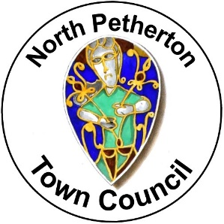
Alfred Jewel Awards Nomination Form 2026

Please return completed forms to the Town Council by
noon on 1 September 2026
(contact details are at the bottom of the page)

Eligibility Criteria
- The nominee must live or volunteer in the area covered by North Petherton Town Council
- The award must relate to voluntary activities i.e. not related to paid employment
- The person(s) making the nomination must live, work or volunteer in North Petherton
- Nominees must not have been in receipt of an Alfred Jewel Award in the past 5 years

- Name of Nominee:

- Contact Details for Nominee (postal address and email):

- Name of person making nomination:

- Contact details of person making nomination (postal address and email):

- Details of what the nominee is doing / has done which has benefitted the area covered by North Petherton Town Council and its residents. Please continue on a separate sheet if necessary:

